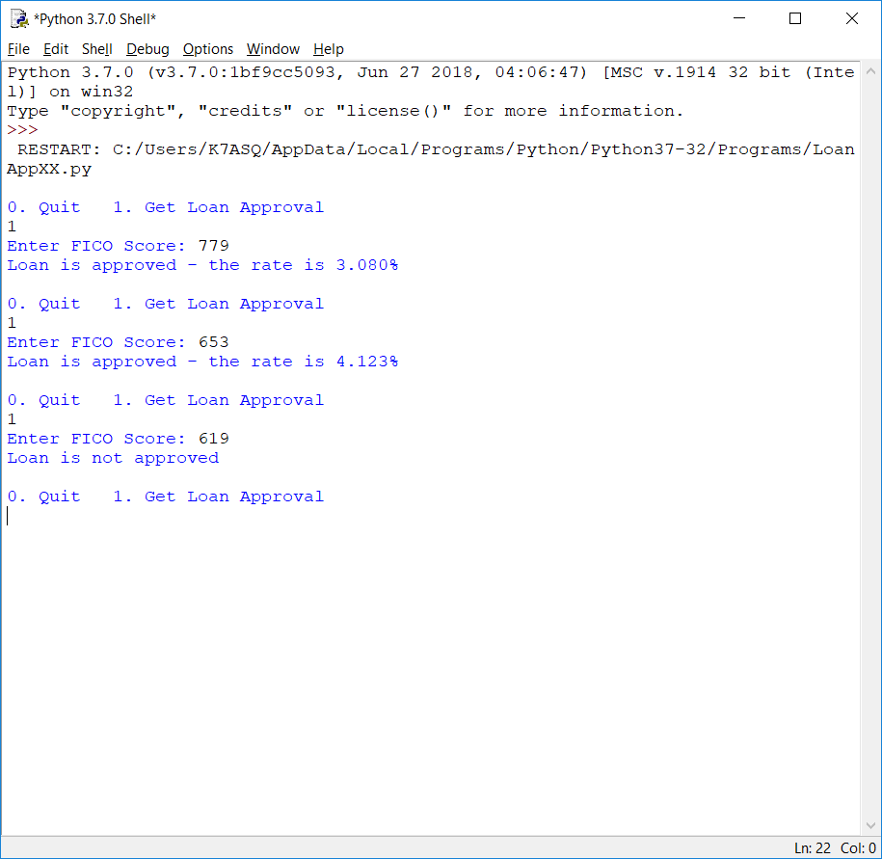

This week was fun. I decided to make the program “user friendly” by prompting for FICO scores instead of typing function names and passing variables, or hard-coding the scores in. I also coded it to run over and over again until the user decides to stop instead of re-executing the program after each run. I went with three functions. A main function for the menu and flow control, an approval function with the logic from last week, and an output function to display the results. Functions came in very handy for making this happen. In fact, I don’t know how I would have done it without functions and the ability to call main() to essentially restart the program after processing each FICO score. Along the way, I experimented with global variables instead of a return statement. It only served to made things more confusing, so that file went into the recycle bin. I tried to account for numbers other than 0 or 1 being accidentally entered at the menu, but we haven’t learned exception and error handling yet, so anything else will cause the program to crash. The same if anything other than a number is entered as a FICO score.